

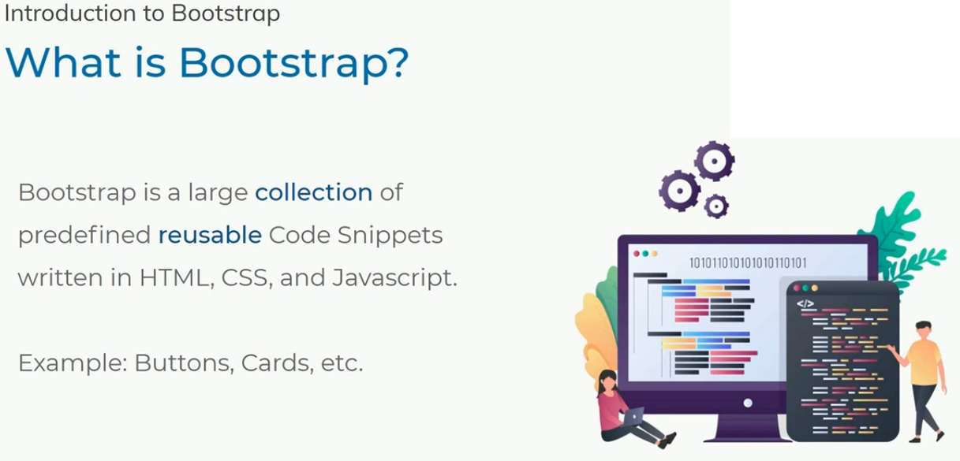

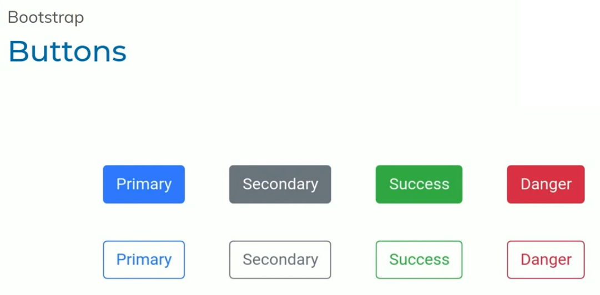

**These are the Common Thinks in websites**

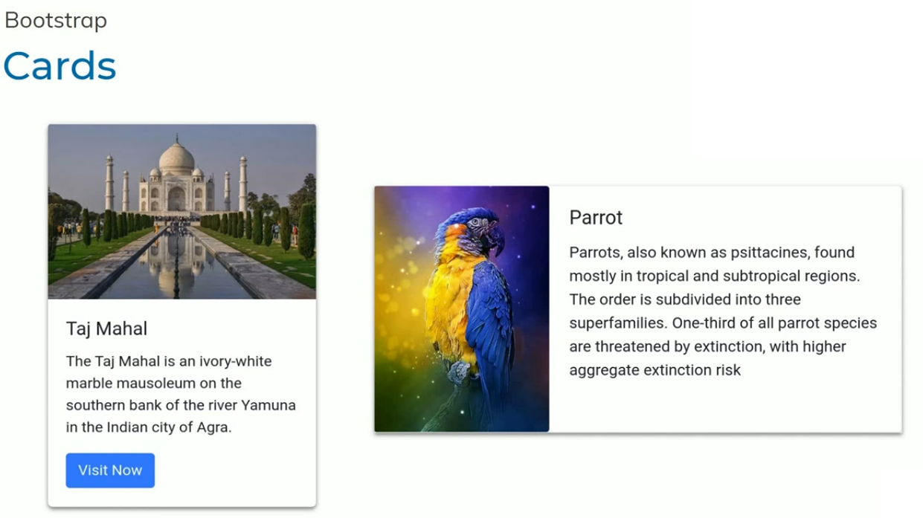

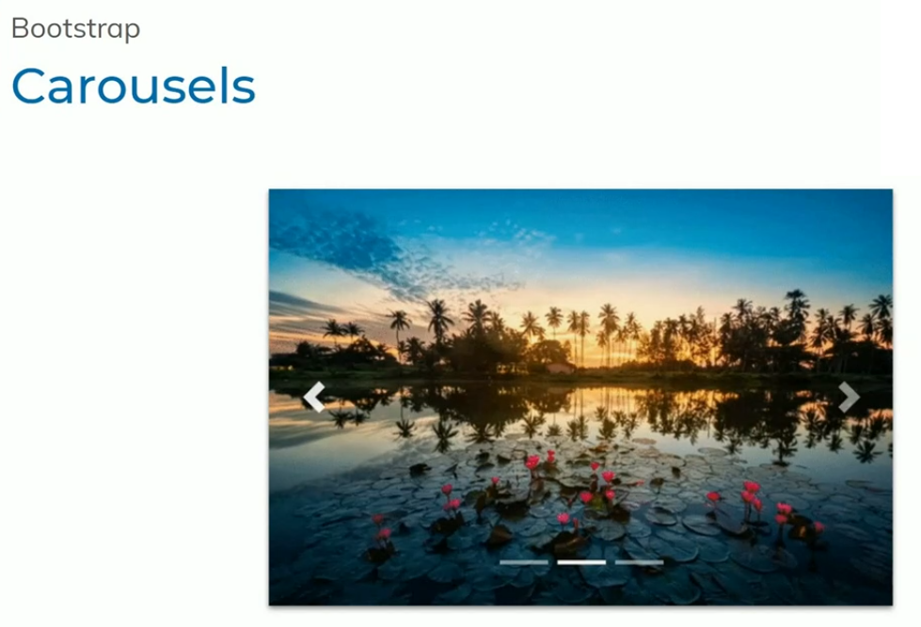

**Carousels are to add slides to images**

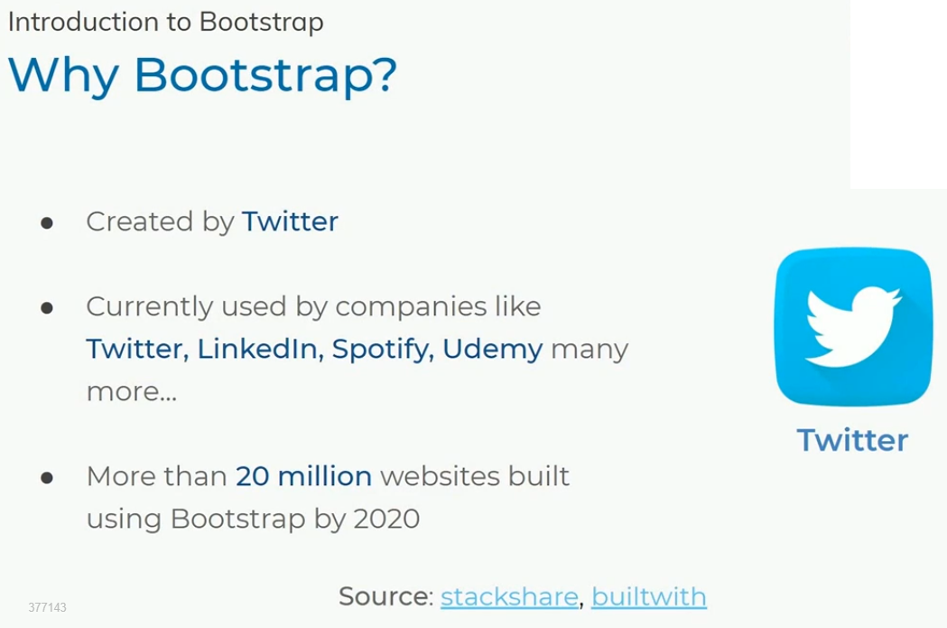

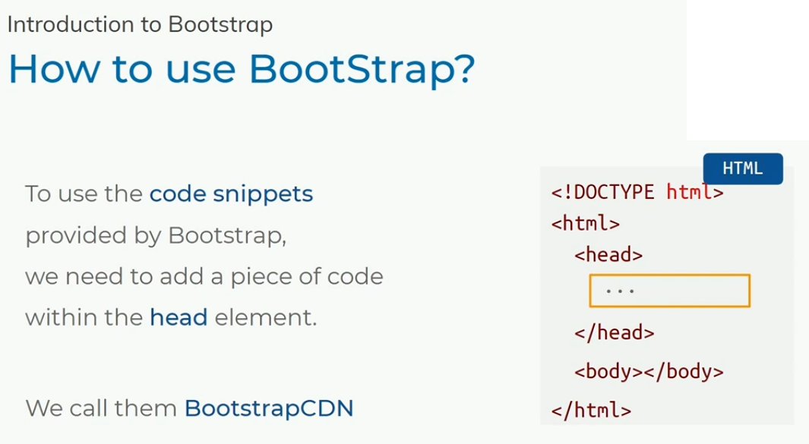

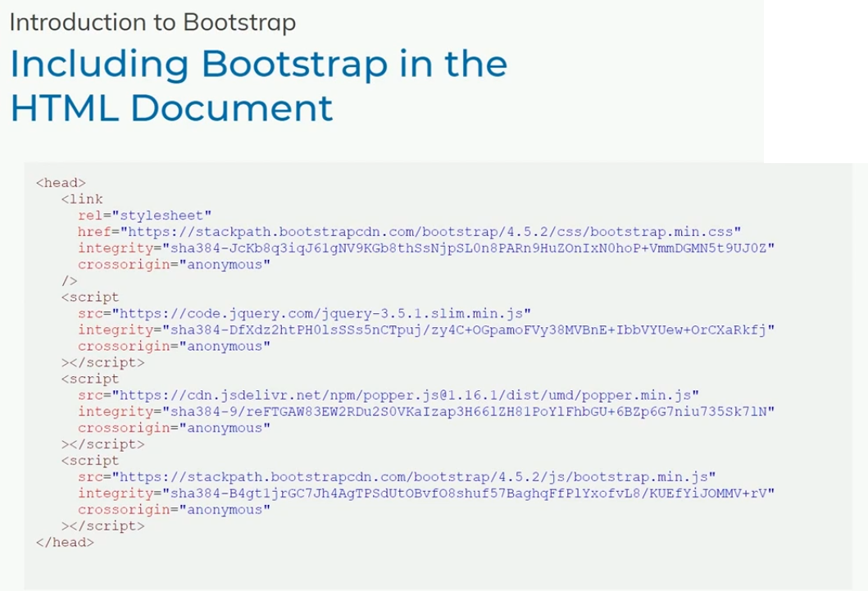

**<link rel="stylesheet" href="https://stackpath.bootstrapcdn.com/bootstrap/4.5.2/css/bootstrap.min.css" integrity="sha384-JcKb8q3iqJ61gNV9KGb8thSsNjpSL0n8PARn9HuZOnIxN0hoP+VmmDGMN5t9UJ0Z" crossorigin="anonymous">**

**<script src="https://code.jquery.com/jquery-3.5.1.slim.min.js" integrity="sha384-DfXdz2htPH0lsSSs5nCTpuj/zy4C+OGpamoFVy38MVBnE+IbbVYUew+OrCXaRkfj" crossorigin="anonymous"></script>**

**<script src="https://cdn.jsdelivr.net/npm/popper.js@1.16.1/dist/umd/popper.min.js" integrity="sha384-9/reFTGAW83EW2RDu2S0VKaIzap3H66lZH81PoYlFhbGU+6BZp6G7niu735Sk7lN" crossorigin="anonymous"></script>**

**<script src="https://stackpath.bootstrapcdn.com/bootstrap/4.5.2/js/bootstrap.min.js" integrity="sha384-B4gt1jrGC7Jh4AgTPSdUtOBvfO8shuf57BaghqFfPlYxofvL8/KUEfYiJOMMV+rV" crossorigin="anonymous"></script>**

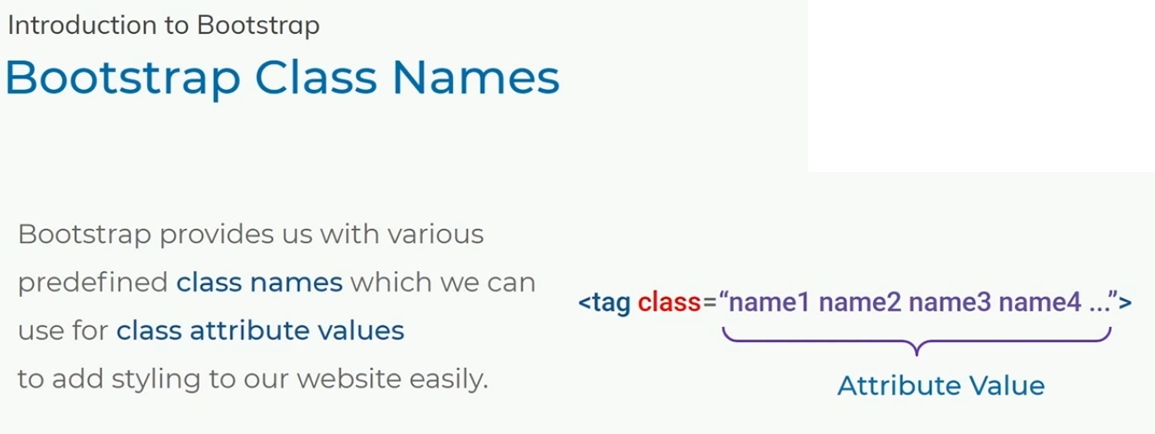

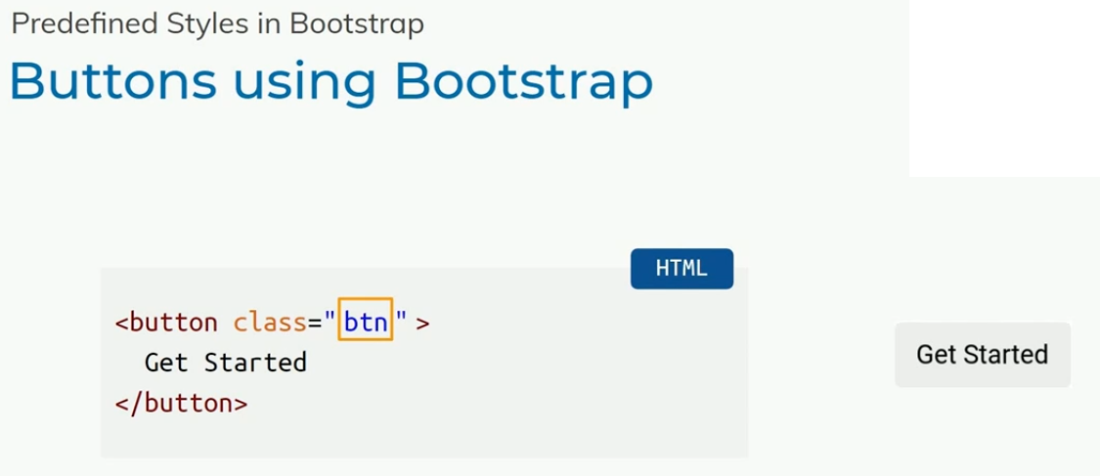

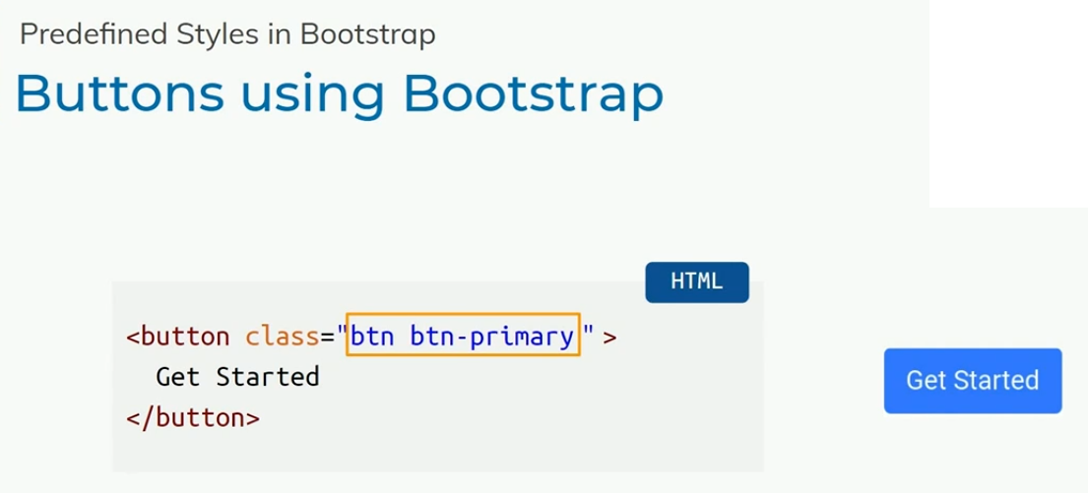

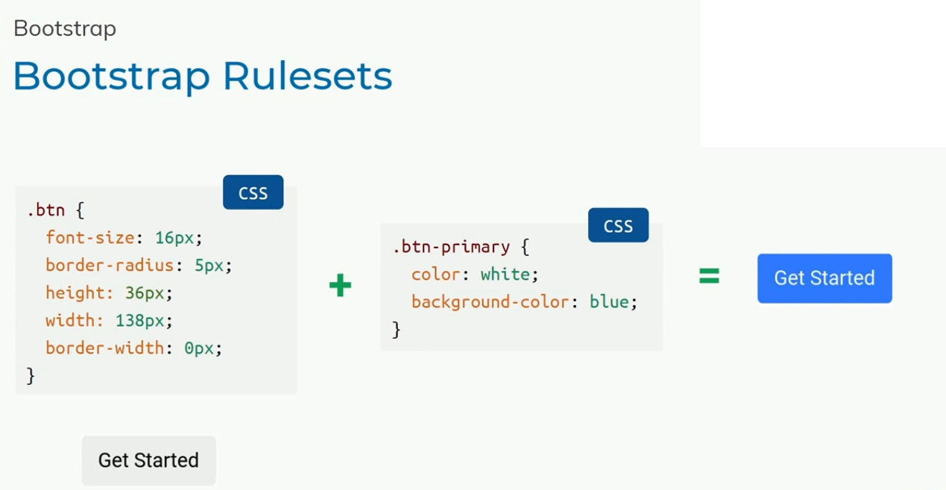

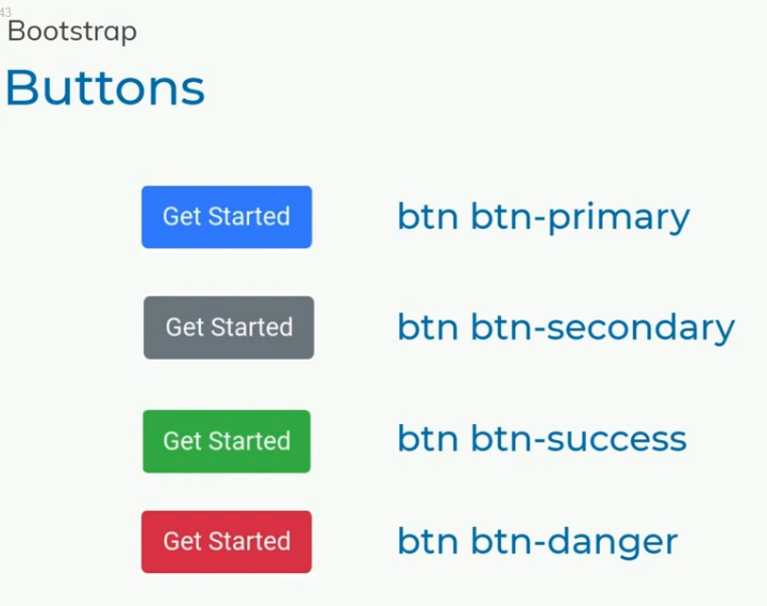

**<!DOCTYPE html>**

**<html>**

**<head>**

**<link rel="stylesheet" href="https://stackpath.bootstrapcdn.com/bootstrap/4.5.2/css/bootstrap.min.css" integrity="sha384-JcKb8q3iqJ61gNV9KGb8thSsNjpSL0n8PARn9HuZOnIxN0hoP+VmmDGMN5t9UJ0Z" crossorigin="anonymous">**

**<script src="https://code.jquery.com/jquery-3.5.1.slim.min.js" integrity="sha384-DfXdz2htPH0lsSSs5nCTpuj/zy4C+OGpamoFVy38MVBnE+IbbVYUew+OrCXaRkfj" crossorigin="anonymous"></script>**

**<script src="https://cdn.jsdelivr.net/npm/popper.js@1.16.1/dist/umd/popper.min.js" integrity="sha384-9/reFTGAW83EW2RDu2S0VKaIzap3H66lZH81PoYlFhbGU+6BZp6G7niu735Sk7lN" crossorigin="anonymous"></script>**

**<script src="https://stackpath.bootstrapcdn.com/bootstrap/4.5.2/js/bootstrap.min.js" integrity="sha384-B4gt1jrGC7Jh4AgTPSdUtOBvfO8shuf57BaghqFfPlYxofvL8/KUEfYiJOMMV+rV" crossorigin="anonymous"></script>**

**</head>**

**<body>**

**<button class="btn btn-primary">Get Started</button>**

**<button class="btn btn-secondary">Get Started</button>**

**<button class="btn btn-success">Get Started</button>**

**<button class="btn btn-danger">Get Started</button>**

**<button class="btn btn-warning">Get Started</button>**

**<button class="btn btn-info">Get Started</button>**

**<button class="btn btn-light">Get Started</button>**

**<button class="btn btn-dark">Get Started</button>**

**</body>**

**</html>**

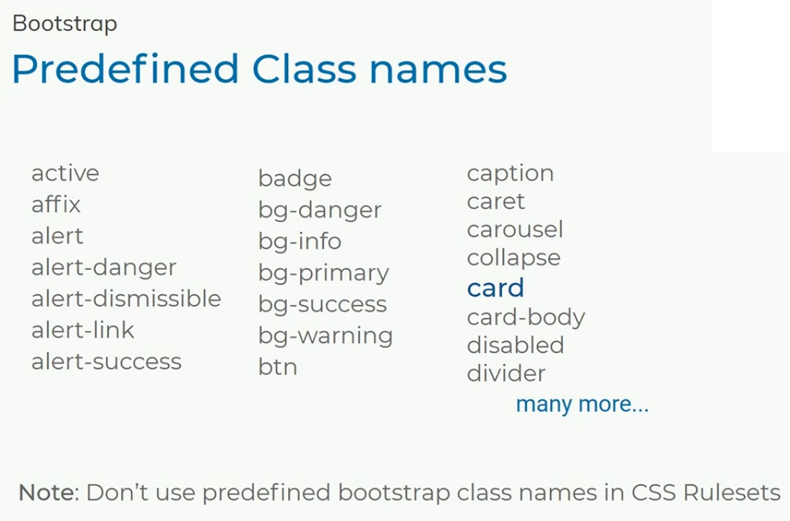

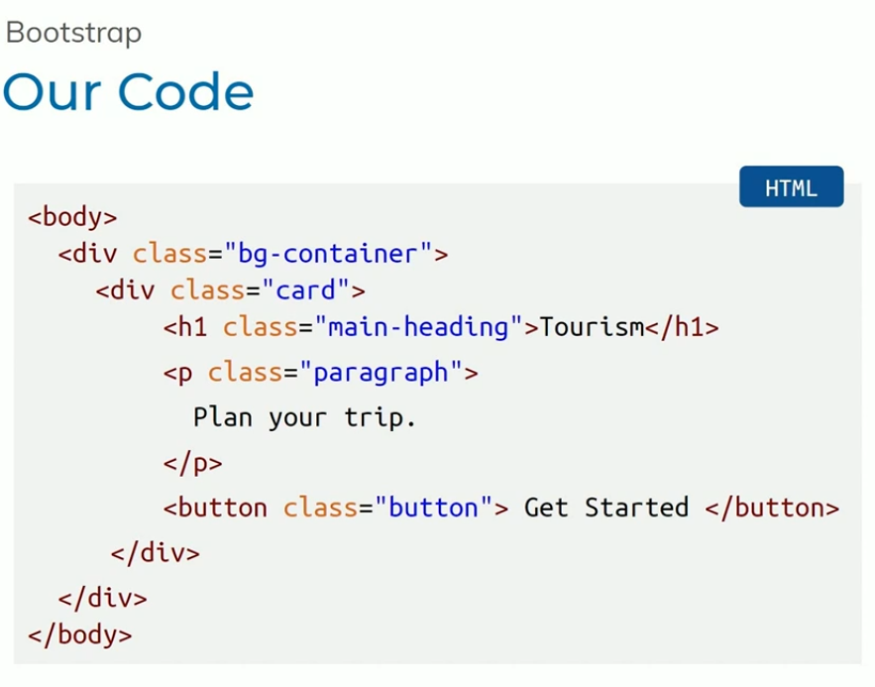

**When we use code like this here we have a chance to undeserved behaviour**

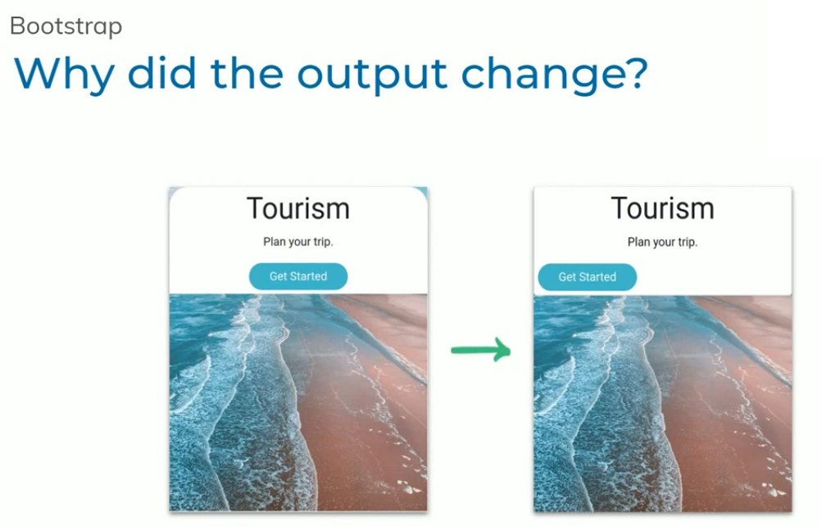

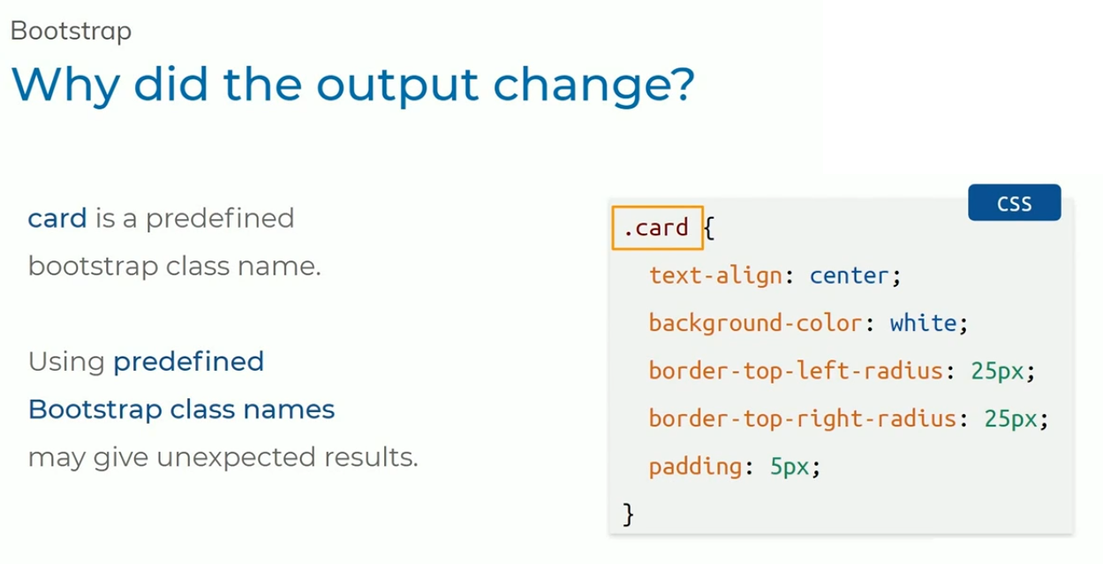

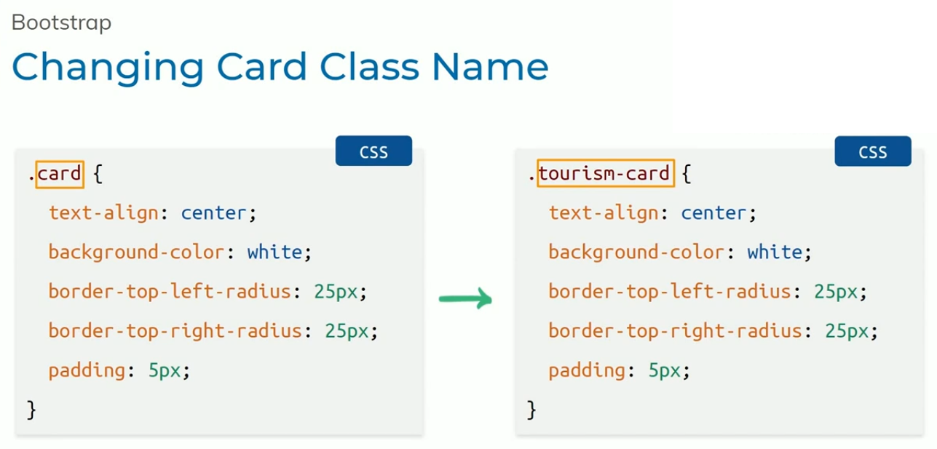

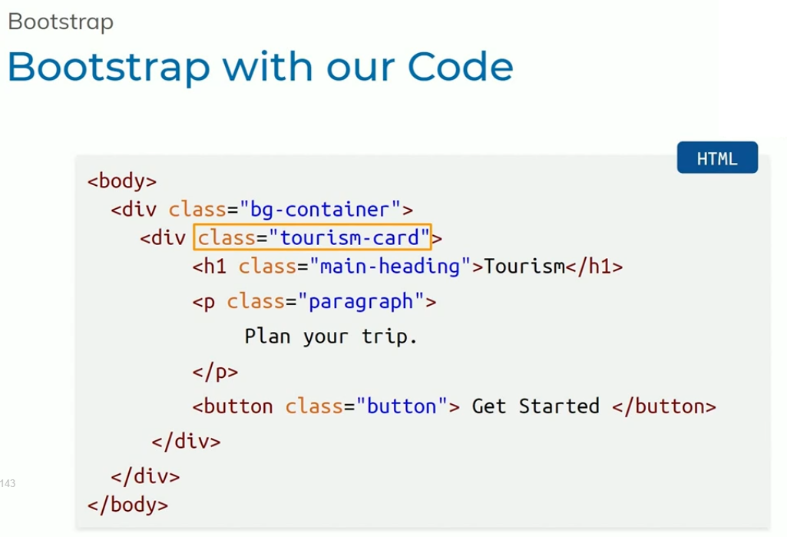

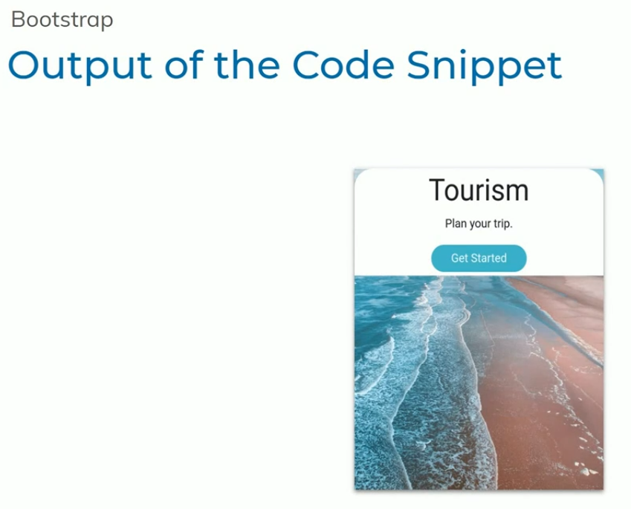

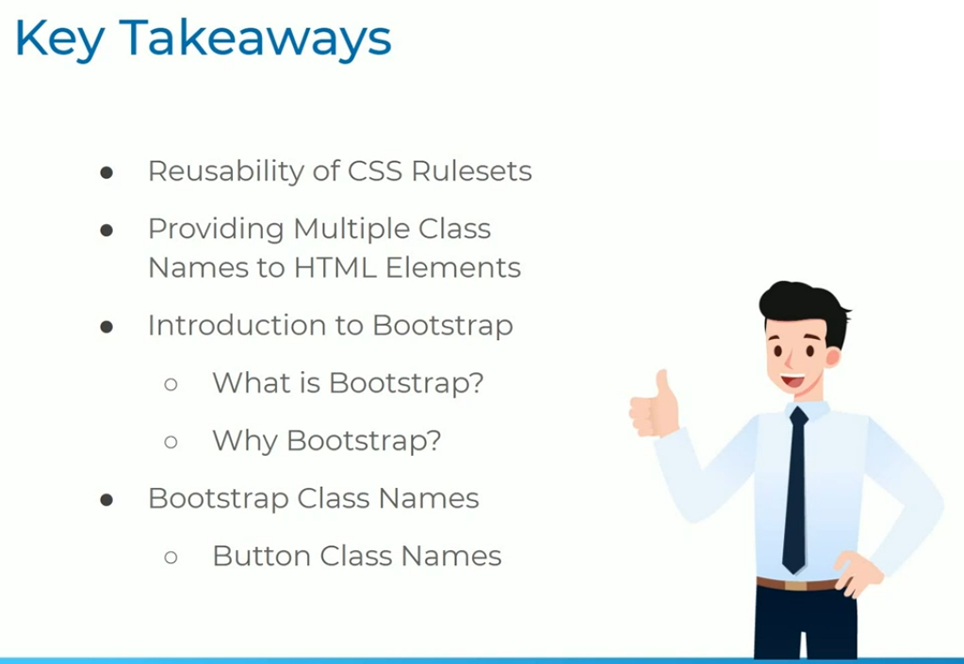

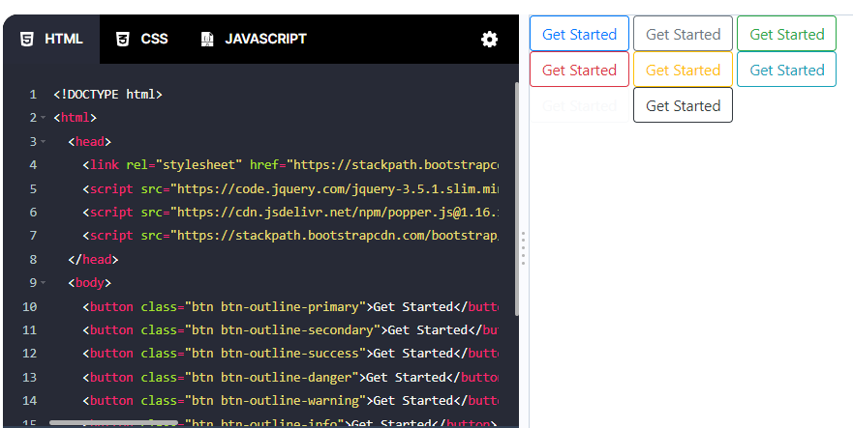

**<!DOCTYPE html>**

**<html>**

**<head>**

**<link rel="stylesheet" href="https://stackpath.bootstrapcdn.com/bootstrap/4.5.2/css/bootstrap.min.css" integrity="sha384-JcKb8q3iqJ61gNV9KGb8thSsNjpSL0n8PARn9HuZOnIxN0hoP+VmmDGMN5t9UJ0Z" crossorigin="anonymous">**

**<script src="https://code.jquery.com/jquery-3.5.1.slim.min.js" integrity="sha384-DfXdz2htPH0lsSSs5nCTpuj/zy4C+OGpamoFVy38MVBnE+IbbVYUew+OrCXaRkfj" crossorigin="anonymous"></script>**

**<script src="https://cdn.jsdelivr.net/npm/popper.js@1.16.1/dist/umd/popper.min.js" integrity="sha384-9/reFTGAW83EW2RDu2S0VKaIzap3H66lZH81PoYlFhbGU+6BZp6G7niu735Sk7lN" crossorigin="anonymous"></script>**

**<script src="https://stackpath.bootstrapcdn.com/bootstrap/4.5.2/js/bootstrap.min.js" integrity="sha384-B4gt1jrGC7Jh4AgTPSdUtOBvfO8shuf57BaghqFfPlYxofvL8/KUEfYiJOMMV+rV" crossorigin="anonymous"></script>**

**</head>**

**<body>**

**<button class="btn btn-outline-primary">Get Started</button>**

**<button class="btn btn-outline-secondary">Get Started</button>**

**<button class="btn btn-outline-success">Get Started</button>**

**<button class="btn btn-outline-danger">Get Started</button>**

**<button class="btn btn-outline-warning">Get Started</button>**

**<button class="btn btn-outline-info">Get Started</button>**

**<button class="btn btn-outline-light">Get Started</button>**

**<button class="btn btn-outline-dark">Get Started</button>**

**</body>**

**</html>**

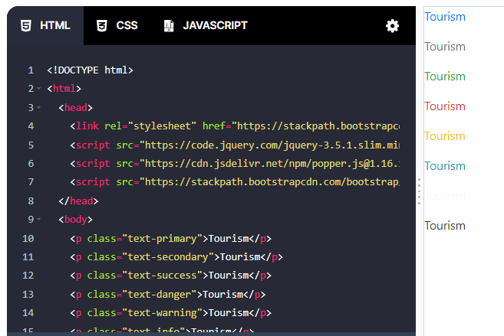

**<!DOCTYPE html>**

**<html>**

**<head>**

**<link rel="stylesheet" href="https://stackpath.bootstrapcdn.com/bootstrap/4.5.2/css/bootstrap.min.css" integrity="sha384-JcKb8q3iqJ61gNV9KGb8thSsNjpSL0n8PARn9HuZOnIxN0hoP+VmmDGMN5t9UJ0Z" crossorigin="anonymous">**

**<script src="https://code.jquery.com/jquery-3.5.1.slim.min.js" integrity="sha384-DfXdz2htPH0lsSSs5nCTpuj/zy4C+OGpamoFVy38MVBnE+IbbVYUew+OrCXaRkfj" crossorigin="anonymous"></script>**

**<script src="https://cdn.jsdelivr.net/npm/popper.js@1.16.1/dist/umd/popper.min.js" integrity="sha384-9/reFTGAW83EW2RDu2S0VKaIzap3H66lZH81PoYlFhbGU+6BZp6G7niu735Sk7lN" crossorigin="anonymous"></script>**

**<script src="https://stackpath.bootstrapcdn.com/bootstrap/4.5.2/js/bootstrap.min.js" integrity="sha384-B4gt1jrGC7Jh4AgTPSdUtOBvfO8shuf57BaghqFfPlYxofvL8/KUEfYiJOMMV+rV" crossorigin="anonymous"></script>**

**</head>**

**<body>**

**<p class="text-primary">Tourism</p>**

**<p class="text-secondary">Tourism</p>**

**<p class="text-success">Tourism</p>**

**<p class="text-danger">Tourism</p>**

**<p class="text-warning">Tourism</p>**

**<p class="text-info">Tourism</p>**

**<p class="text-light">Tourism</p>**

**<p class="text-dark">Tourism</p>**

**</body>**

**</html>**

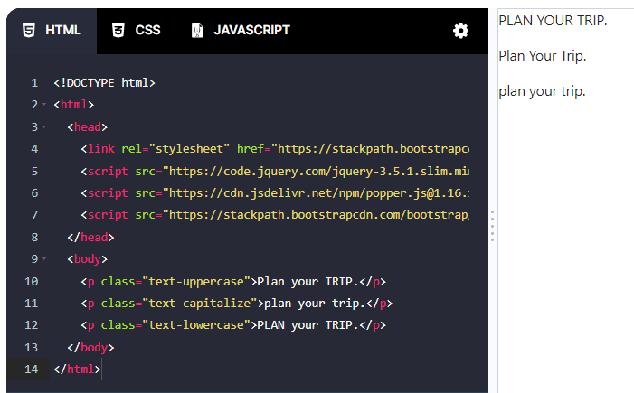

**<!DOCTYPE html>**

**<html>**

**<head>**

**<link rel="stylesheet" href="https://stackpath.bootstrapcdn.com/bootstrap/4.5.2/css/bootstrap.min.css" integrity="sha384-JcKb8q3iqJ61gNV9KGb8thSsNjpSL0n8PARn9HuZOnIxN0hoP+VmmDGMN5t9UJ0Z" crossorigin="anonymous">**

**<script src="https://code.jquery.com/jquery-3.5.1.slim.min.js" integrity="sha384-DfXdz2htPH0lsSSs5nCTpuj/zy4C+OGpamoFVy38MVBnE+IbbVYUew+OrCXaRkfj" crossorigin="anonymous"></script>**

**<script src="https://cdn.jsdelivr.net/npm/popper.js@1.16.1/dist/umd/popper.min.js" integrity="sha384-9/reFTGAW83EW2RDu2S0VKaIzap3H66lZH81PoYlFhbGU+6BZp6G7niu735Sk7lN" crossorigin="anonymous"></script>**

**<script src="https://stackpath.bootstrapcdn.com/bootstrap/4.5.2/js/bootstrap.min.js" integrity="sha384-B4gt1jrGC7Jh4AgTPSdUtOBvfO8shuf57BaghqFfPlYxofvL8/KUEfYiJOMMV+rV" crossorigin="anonymous"></script>**

**</head>**

**<body>**

**<p class="text-uppercase">Plan your TRIP.</p>**

**<p class="text-capitalize">plan your trip.</p>**

**<p class="text-lowercase">PLAN your TRIP.</p>**

**</body>**

**</html>**

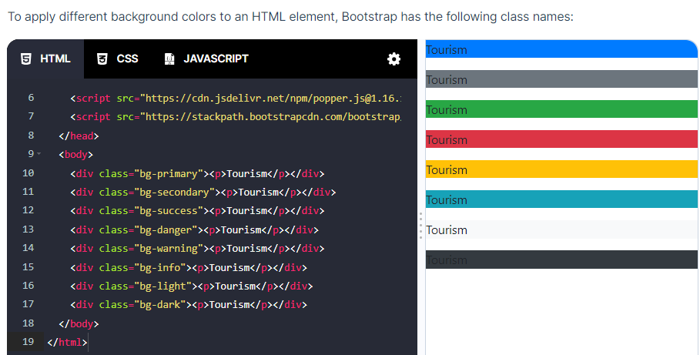

**<!DOCTYPE html>**

**<html>**

**<head>**

**<link rel="stylesheet" href="https://stackpath.bootstrapcdn.com/bootstrap/4.5.2/css/bootstrap.min.css" integrity="sha384-JcKb8q3iqJ61gNV9KGb8thSsNjpSL0n8PARn9HuZOnIxN0hoP+VmmDGMN5t9UJ0Z" crossorigin="anonymous">**

**<script src="https://code.jquery.com/jquery-3.5.1.slim.min.js" integrity="sha384-DfXdz2htPH0lsSSs5nCTpuj/zy4C+OGpamoFVy38MVBnE+IbbVYUew+OrCXaRkfj" crossorigin="anonymous"></script>**

**<script src="https://cdn.jsdelivr.net/npm/popper.js@1.16.1/dist/umd/popper.min.js" integrity="sha384-9/reFTGAW83EW2RDu2S0VKaIzap3H66lZH81PoYlFhbGU+6BZp6G7niu735Sk7lN" crossorigin="anonymous"></script>**

**<script src="https://stackpath.bootstrapcdn.com/bootstrap/4.5.2/js/bootstrap.min.js" integrity="sha384-B4gt1jrGC7Jh4AgTPSdUtOBvfO8shuf57BaghqFfPlYxofvL8/KUEfYiJOMMV+rV" crossorigin="anonymous"></script>**

**</head>**

**<body>**

**<div class="bg-primary"><p>Tourism</p></div>**

**<div class="bg-secondary"><p>Tourism</p></div>**

**<div class="bg-success"><p>Tourism</p></div>**

**<div class="bg-danger"><p>Tourism</p></div>**

**<div class="bg-warning"><p>Tourism</p></div>**

**<div class="bg-info"><p>Tourism</p></div>**

**<div class="bg-light"><p>Tourism</p></div>**

**<div class="bg-dark"><p>Tourism</p></div>**

**</body>**

**</html>**